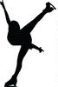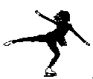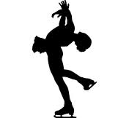

ENTRY FORM FOR SKATERS

13TH EASTERN HUNGARY CUP

International Senior, Junior, Novice, Youngsters, Recreational and Adult
Figure Skating Competition
16-18 November 2018, MISKOLC-HUNGARY

Please, return this form not later than 22 October, 2018

Men
Nr. Name (FAMILY NAME, Given name) Category Date of Birth (DD/MM/YY)
1.
2.
3.

Ladies
Nr. Name (FAMILY NAME, Given name) Category Date of Birth (DD/MM/YY)
1.
2.
3.
4.
6.
7.
8.
9.

ISU Member Federation:

Date, Signature:

