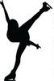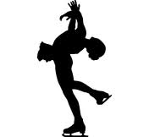

PLANNED PROGRAM CONTENT

13TH EASTERN HUNGARY CUP

International Senior, Junior, Novice, Youngsters, Recreational and Adult
Figure Skating Competition
16-18 November 2018, MISKOLC-HUNGARY

Please, return this form not later than 30 October, 2018

Club Name and Country:
Category:
Name of Competitor(s):

ELEMENTS IN ORDER OF SKATING

 | Elements SP | Elements FP
1
2
3
4
5
6
7
8
9
10

ISU Member Federation:

Date, Signature:

