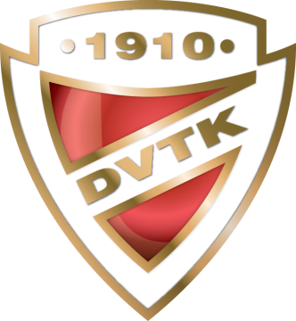
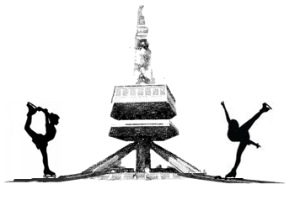
COMPOSITION OF DELEGATION

15. DVTK-AVAS Cup

Interclub Senior, Junior, Novice, Youngsters, Recreational and Adult
Figure Skating Competition
27-29 March 2020, MISKOLC-HUNGARY

Please, return this form not later than 2 March, 2020

Member Federation:
Club Name: |  | Team Leader:
Phone Number: |  | E-mail:

Competitors
Nr. FAMILY NAME Given name Nr. FAMILY NAME Given name
1. |  |  |  | 8.
2. |  |  |  | 9.
3. |  |  |  | 10.
4. |  |  |  | 11.
5. |  |  |  | 12.
6. |  |  |  | 13.
7. |  |  |  | 14.

Judges
Nr. FAMILY NAME Given name Nr. FAMILY NAME Given name
1. |  |  |  | 2.

Coaches
Nr. FAMILY NAME Given name Nr. FAMILY NAME Given name
1. |  |  |  | 3.
2. |  |  |  | 4.

Chaperons
Nr. FAMILY NAME Given name Nr. FAMILY NAME Given name
1. |  |  |  | 4.
2. |  |  |  | 5.
3. |  |  |  | 6.

ISU Member Federation:
Date, Signature:

